

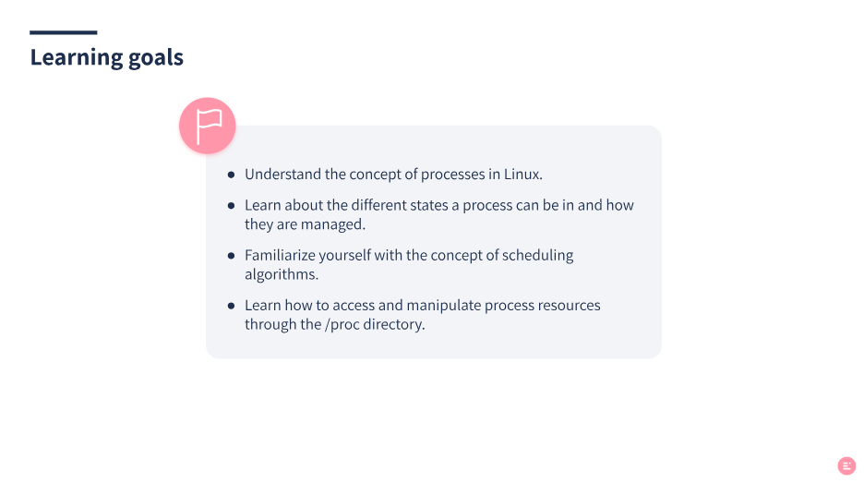
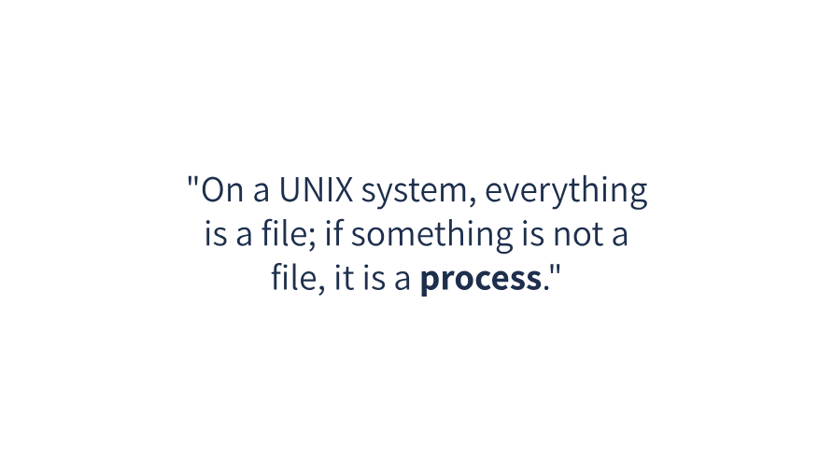
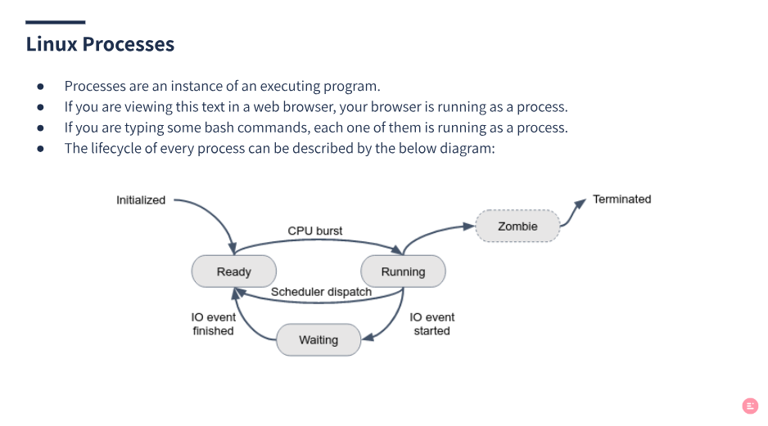
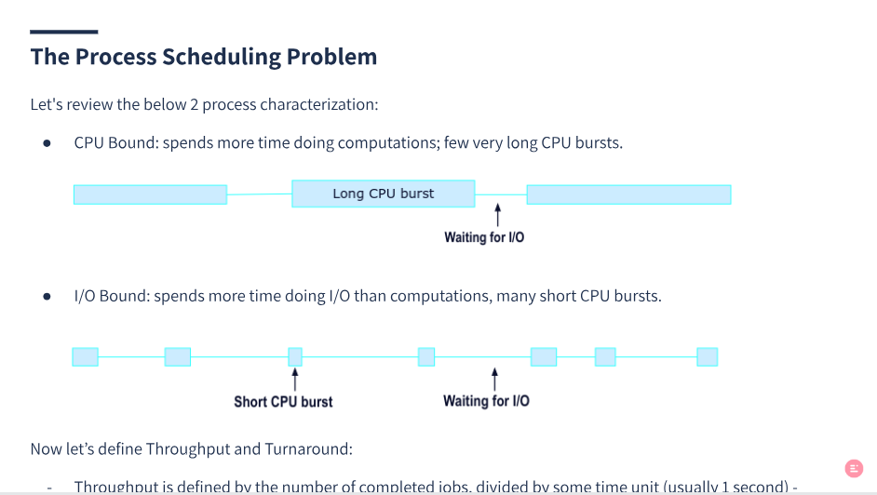
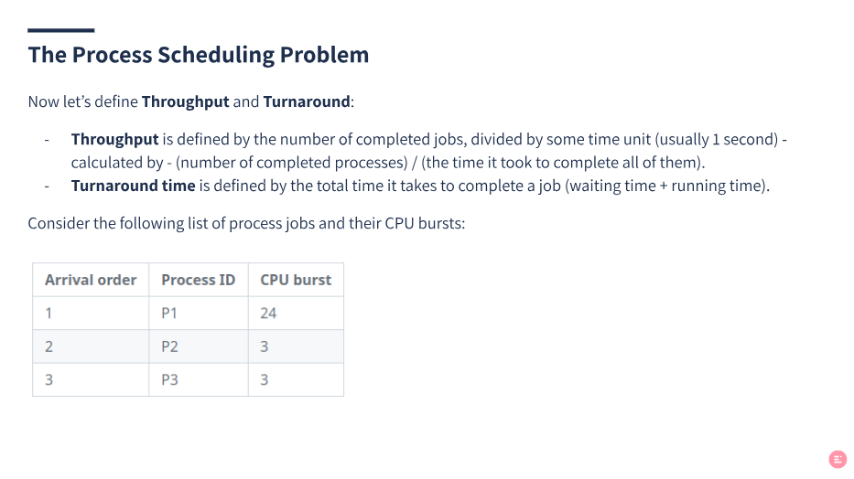
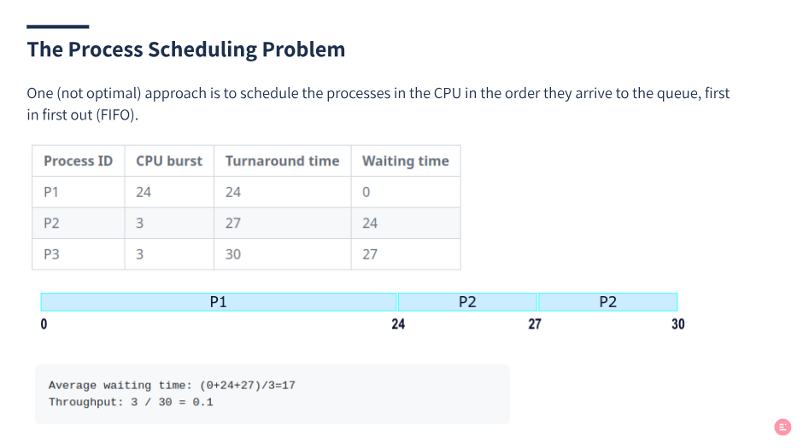
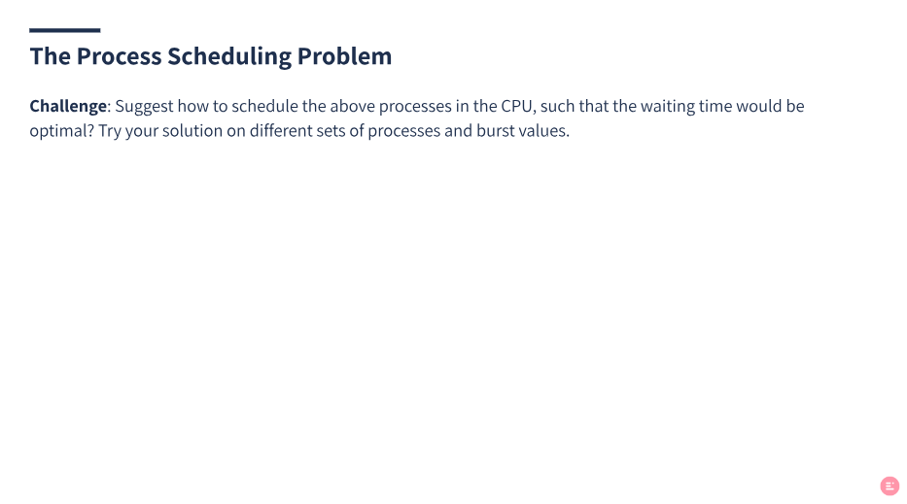
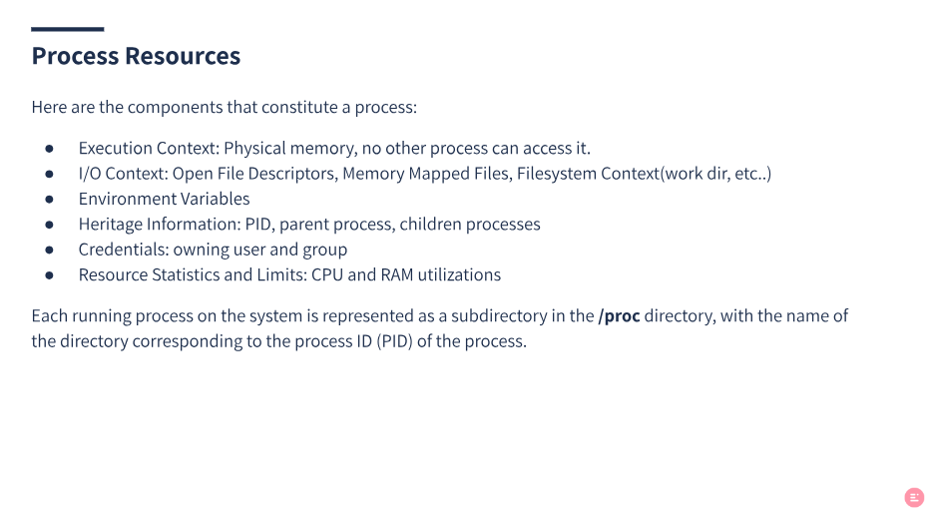
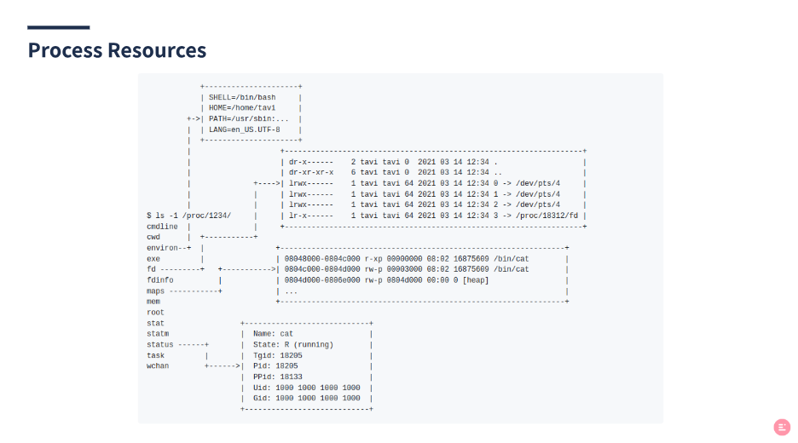
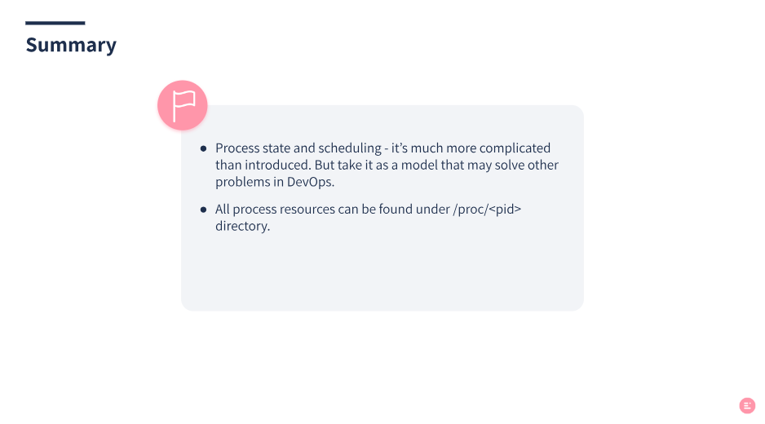


2. Agenda and Learning Goals

This unit will cover:
- Linux processes introduction.
- Process states.
- Signals.
- Linux services.

At the end of this unit you’ll be able to:
- Understand what processes are.
- Think about system behavior and troubleshooting in terms of processes.
- Send signals to processes.
- Manage (and create) linux processes that run as a service.

3. Process Definition
A process is a currently executing program (or command). A program is a series of instructions that tell the computer what to do. When we run a program, those instructions are copied into memory and space is allocated for variables and other stuff required to manage its execution. This running instance of a program is called a process.
The top command can show running processes in the terminal in real-time.
myuser@hostname:~$ top
...

4. Processes State
In linux, multiple users run multiple processes, at the same time and on the same system. The CPU manages all these processes simultaneously, according to the below state diagram:
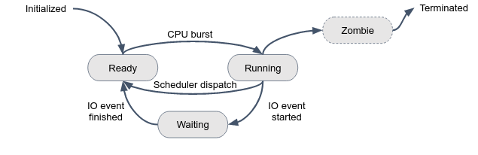
A process can be in one of several states at any given time, indicating its current status or activity. These states are important to understand for managing and troubleshooting system performance.
Here is a short description of each state:
- Running: A process is currently executing on a CPU core (a.k.a process CPU burst).
- Waiting: A process is waiting for some external event, such as user input, disk, or a network I/O operation to complete.
- Ready: Is often used to refer to a process that is waiting to be executed on a CPU. When a process is in the ready state, it is typically placed in a queue, waiting for an available CPU to execute on. Once the CPU becomes available, the process is moved from the ready state to the running state and starts executing. The amount of time a process spends in the ready state is dependent on the scheduling algorithm and the current system load.
- Zombie: A process has completed its execution but its parent process has not yet collected its exit status.
- Initialized: A process that has been created but has not yet been assigned a process identifier (PID)
- Terminated: Indicates that a process has finished its execution and has exited.

5. The Process Tree
A new process is created because an existing one makes an exact copy of itself (forking). This implies a tree structure of processes:
myuser@hostname:~$ pstree
systemd─┬─ModemManager───2*[{ModemManager}]
├─NetworkManager───2*[{NetworkManager}]
├─2*[SACSrv───3*[{SACSrv}]]
├─accounts-daemon───2*[{accounts-daemon}]
├─acpid
├─atd
├─avahi-daemon───avahi-daemon
.
.
.
This child process has the same environment as its parent, only a different process id (PID). When a process ends normally (it is not killed or otherwise unexpectedly interrupted), the program returns its exit code (a number) to the parent. Only an exit status of 0 means success.
A process has a series of characteristics, which can be viewed with the ps command:
myuser@hostname:~$ ps -aux
USER PID %CPU %MEM VSZ RSS TTY STAT START TIME COMMAND
root 1 0.0 0.1 172752 9440 ? Ss 13 Feb 7:21 /sbin/init splash
root 2 0.0 0.0 0 0 ? S 13 Feb 0:00 [kthreadd]
The ps command can display a lot of information about processes, including their PID, state (STAT column), CPU and memory usage, the user owning this process, and the command that initiated the process.

6. Signals
Processes are communicating with each other and with the kernel using signals. There are multiple signals that you can send to a process. Use the kill command to send a signal to a process.
Signal Name | Signal Number | Meaning
SIGTERM | 15 | Terminate the process in orderly way
SIGINT | 2 | Interrupt the process, the process can ignore this signal
SIGKILL | 9 | Interrupt the process, the process can’t ignore this
SIGHUP | 1 | The parent process was terminated

Use man 7 signal for a comprehensive list of linux signals.
Let’s kill a process by send it a KILL signal:

myuser@hostname:~$ sleep 600

The above command initiates a process that just sleeps 600 seconds, and ends.
In another terminal, use ps to get the PID of the process running the sleep command:
myuser@hostname:~$ ps -a
PID TTY TIME CMD
46214 pts/1 00:00:00 sleep
46445 pts/3 00:00:00 ps
...
myuser@hostname:~$ kill -9 46214

Observe how the process running the sleep command is terminated.

In bash, you can use keyboard shortcuts to send signals to process:
Shortcut | Signal | Meaning
CTRL+C | SIGINT | Terminate the process in an orderly way
CTRL+Z | SIGSTOP | Suspend the process in the background

Graceful Termination
We will now demonstrate a very important idea called Graceful Termination.
Graceful termination refers to the process of shutting down a program (a process) in a way that allows it to complete its current tasks and close down all processes in a safe and controlled manner. This ensures that no data is lost, and all system resources are properly released.
In our shared repo, under graceful_term_simulate/server.py you are given a dummy Python "Server". Run this server by:
# You might try 'python' instead 'python3' command
myuser@hostname:~$ python3 graceful_term_simulate/server.py
Server is running, PID=47098

Obviously, we can send SIGKILL (9) to the server and kill it aggressively. But we want the server to be terminated gracefully. To do so, we will first send SIGINT, which indicates to the server "you are going to be terminated soon, so take some grace period to terminate yourself gracefully".
The server finishes the process clients requests, closes the connection to the database, and performs some cleanup tasks. Finally, the server terminates itself, while everything is healthy.

7. Services
In Linux, services are background processes that run continuously and provide specific functions to the operating system or other applications. Here are some common Linux services:
- ssh: A secure remote login protocol that allows users to log in to a remote computer securely.
- cron: A service that executes scheduled tasks or commands at specified intervals.
- ufw: An easy-to-use interface for configuring and managing firewall rules on a Linux system.
- apache: A web server that serves HTML pages and other files over the internet.
The systemctl command is used to manage services in your system:

myuser@hostname:~$ sudo systemctl status ufw
● ufw.service - Uncomplicated firewall
Loaded: loaded (/lib/systemd/system/ufw.service; enabled; vendor preset: enabled)
Active: active (exited) since Sun 2022-01-01 07:25:58 UTC; 2h 16min ago
Docs: man:ufw(8)
Main PID: 338 (code=exited, status=0/SUCCESS)
CPU: 1ms

Jan 01 07:25:58 hostname systemd[1]: Starting Uncomplicated firewall...
Jan 01 07:25:58 hostname systemd[1]: Finished Uncomplicated firewall.
myuser@hostname:~$ sudo systemctl stop ufw
myuser@hostname:~$ sudo systemctl start ufw
myuser@hostname:~$ sudo systemctl restart <service name>

Enable a service to start automatically at boot time by:

sudo systemctl enable <service name>

Who manages Linux services?
As can be seen in the output of pstree, systemd is the first process in many Linux distributions, which is a system and service manager that provides a way to manage and control system services. Systemd reads unit files, which are configuration files used by systemd to define system services.
Unit files can be found in the /etc/systemd/system directory:
myuser@hostname:~$ ls /etc/systemd/system/*.service
/etc/systemd/system/sshd.service
/etc/systemd/system/mysql.service
/etc/systemd/system/jenkins.service
...
List all your system services:
myuser@hostname:~$ systemctl list-units --type=service
UNIT LOAD ACTIVE SUB DESCRIPTION
accounts-daemon.service loaded active running Accounts Service
acpid.service loaded active running ACPI event daemon
alsa-restore.service loaded active exited Save/Restore Sound Card
....
In the above output, UNIT represents the unit name, LOAD indicates that the unit’s configuration has been read by systemd, ACTIVE is the state of the unit.

8. Spot Check
- How many days is the systemd-resolved service running?
- Is ufw service active in your system? Is it running? If not, what is the exit code of the process that runs the service?
- What is the PID of the systemd-timesyncd service? Restart the service, what is the PID? What is this service responsible for?
- Check the status of service ssh. Send SIGKILL to the process ID of this service. What happened to the service? Check the status, what is the status, why?
Solution
- Execute systemctl status systemd-resolved, the information is there.
- Execute systemctl status ufw, usually the service is active but not running. The exit code is 0 (code=exited, status=0/SUCCESS).
- Execute systemctl status systemd-timesyncd, the PID is Main PID: 596. Restart the service by sudo systemctl status systemd-timesyncd. The PID may change. The service is responsible for synchronizing the system clock across the network with a remote server using the Network Time Protocol (NTP).
- Execute systemctl status ssh, the service should be active and running. Kill the main process of the service by kill -9 <ssh-pid>, while <ssh-pid> is the process id of the service. If you send a SIGKILL signal to the process ID of the SSH service, the service will be abruptly terminated. Usually, this service has been configured to automatically restart after a failure or unexpected termination, so the service status should be active and running (with different PID).

9. Exercises

Exercise 1 - Run processes in the background
“Interactive processes” are processes that are initialized and controlled through a Linux terminal session. These processes can run in the foreground, occupying the terminal. Alternatively, they can run in the background. The terminal can accept new commands while the program is running.
- Open a nes terminal session and execute sleep 600 which initiates a process that “sleeps” 10 minutes and ends.
- Stop the process and send it into the background by CTRL+Z.
- Bring the process to the foreground by fg.
- Now run the same command while sending the process to the background by the & operator: sleep 600 &.
- Bring the process to the foreground.
- Kill the process by CTRL+C.

Exercise 2 - Run your own service
Follow Pratham Patel's great tutorial to create your own Linux service

Exercise 3 - Resource Lock and Process State
Resource locking is a technique used in computer systems to prevent multiple processes (or users) from simultaneously accessing a shared resource such as a file, database, or piece of memory.
The general idea behind resource locking is to ensure that only one person can access the resource at any given time, to prevent race conditions and other synchronization issues that could lead to data corruption or inconsistencies.
As a real life example, in an airline online check-in system, resource locking may be used to prevent multiple users from simultaneously booking the same seat. Only one user should be able to book a certain seat in the aircraft at any given time, to prevent conflicts and ensure data consistency.
Throughout the course, we will encounter resource locking in many cases.
Generally speaking, in Linux systems, two different processes cannot write to the same file concurrently (exactly at the same moment). Each process needs to obtain an exclusive write lock for the file. That implies that all the other processes that want to write to this file will have to wait while one process writes its data into it. The more I/O intensive processes you have, the longer the wait time.
In this question we will create processes which are competing on the same resource (same file), and see how some of them are changing their state from Running to Waiting.
Create a file under ~/write_to_file_sequentially.sh contains the following code, and give it executable (x) permissions:
#!/bin/bash

for i in $(seq 1000); do
echo "hello world" > overloaded_file
done
This script writes the string “hello world” to a file called "overloaded_file". It does so 1000 times sequentially, and so will never be competing for access to the file (why?).
Now, because we need multiple processes competing over the same resource, create the following script as well:
#!/bin/bash

for i in $(seq 1000); do
./write_to_file_sequentially.sh &
done

Name it ~/multi_process_file_writing.sh and make it executable. Make sure you understand what this script does.
Run the following commands, in 3 different terminal sessions:
- First, in terminal 1, run the program by ./multi_process_file_writing.sh.
- Next, run the top command in terminal 2. Observe the multi_process_file_writing process in top’s view.
In the last terminal you will try to catch processes of your program in different states.
In the ps man page, read what each process state code means.
- In terminal 3, run the ps -aux multiple times until you’ll see indications that some processes are waiting (sleeping due to IO operation), and some others are running.
While you’ll find many processes in a waiting state (D), it may be hard to catch a process in a running state (R)… Use the grep command to filter only relevant lines.

10. Comprehension Check
Welcome to the Comprehension Check. In this section, you will be applying what you learned and choosing the best answer.

Question 1
A user started a process and logged out from the terminal. Which command di he use if the process is still running in the background:
nokill
nohup
nofg
bg
answer: nohup

Question 2
Which of the following is a true statement?
Only the root user may run processes from a shell.
The shell is a process that is commonly used to execute other processes.
The shell is the kernel component that interacts directly with hardware.
Only one instance of a shell may be running as a process.
Answer:2

Question 3
Which of the following is not true for the Linux operating system?
Multiple processes appear to be running at the same time.
Only one instance of any given program may be running as a process.
Programs are stored as files in the filesystem.
Only one instance of the kernel may be running at any given time.
Answer : 2

Question 4
Open a new terminal session and type the command python. Then send a SIGINT signal using your keyboard. What best describes how the python process responds to the SIGINT signal? (you can exit this process by typing exit() in the python console)
The program ignores the SIGINT signal
The program has implemented a custom signal handler for the SIGINT signal.
The program behaves as the kernel’s default signal handler for the SIGINT signal, which is to terminate the process.
The program behaves as the kernel’s default signal handler for the SIGINT signal, which is to stop (suspend) the process.
None of the above
Answer : 2

Question 5
Given the below terminal output:
myuser@localhost:~$ sleep 600 &
myuser@localhost:~$ sleep 600 &
myuser@localhost:~$ sleep 600 &
Which command could be used to know how many processes are running in the background terminal session?
process
jobs
work
list
answer : 2

Question 6
Given a terminal session with a long process running in it, how will you ask this process to terminate?
CTRL+z
CTRL+c
CTRL+l
CTRL+c twice
Answer : 2

Question 7
Given a terminal session with a long process running in it, how will you ask this process to stop?
CTRL+z
CTRL+c
CTRL+l
CTRL+c twice

Answer : 1

Question 8
How would you run the sleep 10 command as a foreground process?
fg sleep 10
sleep 10 &
foreground sleep 10
sleep 10
answer : 4
Given the following output:
[maxwell@station maxwell]$ ps -U maxwell
PID TTY TIME CMD
4785 ? 00:00:00 gnome-session
4828 ? 00:00:00 ssh-agent
...
4846 ? 00:00:00 xscreensaver
5410 pts/8 00:00:00 bash
5451 ? 00:00:00 same-gnome
5452 ? 00:00:00 same-gnome
5454 ? 00:00:01 gimp
5455 ? 00:00:00 script-fu
5463 pts/8 00:00:00 ps
5907 pts/7 00:00:00 bash
5942 pts/7 00:00:00 find

Answer the next 3 questions:

Question 9
Which of the following commands would deliver a SIGTERM to the xscreensaver process?
kill TERM xscreensaver
kill 4846
kill xscreensaver
kill -9 4849
None of the above
Answer : 2

Question 10
Which of the following would deliver a SIGKILL to the xscreensaver command?
kill -9 4846
kill xscreensaver
kill -KILL xscreensaver
kill -15 4846
None of the above
Answer : 1

Question 11
Which of the following would send a SIGCHLD (signal number 17) to the ssh-agent process?
kill -CHLD ssh-agent
kill -17 ssh-agent
kill -CHLD 4828
All of the above
A and C only
Answer : 3

Question 12
Which key pressed within the top command allows the user to send a signal to a process?
s
z
t
k
None of the above
Answer : 4

Question 13
The kill command always terminates a process.
True
False
Answer : 2

